

**Software Report**

**School Management System**

**Version 1.0**

**Prepared by: W. M. L. D. Weerasinghe**

**Date: ……………………………………..**

**Approved by: …………………………………………………..**

Contents

1. Executive Summary 3

2. System Overview 3

2.1 Purpose 3

2.2 Scope 3

3. Technical Specifications 4

3.1 System Architecture 4

3.2 Deployment 4

4. Functional Requirements Implementation 5

5. Non-Functional Requirements Achievement 5

6. User Interface Overview 6

6.1 Loading screen 6

6.2 Secure login interface 7

6.3 Home dashboard with navigation 8

6.4 Principal management screens (Current Principle/view/edit) 9

6.5 Teacher management screens (view/edit) 11

6.6 Student management screens (view/edit) 12

6.7 Admin registration interface 13

7. Development Process 13

7.1 SDLC Timeline 13

7.2 Key Diagrams 14

7.2.1 Entity-Relationship (ER) Diagram 14

7.2.2 Data Flow Diagrams (Level 0) 15

7.2.3 Data Flow Diagrams (Level 1) 16

7.2.4 Use Case Diagram 17

8. Testing Results 17

9. Challenges and Solutions 18

10. Conclusion and Future Work 18

11. Appendix 18

# 1. Executive Summary

This report documents the development and implementation of the School Management System (SMS), a standalone desktop application designed to streamline administrative operations in educational institutions. The system provides comprehensive tools for managing student records, teacher data, and principal information with secure role-based access control.

# 2. System Overview

## 2.1 Purpose

**The SMS was developed to:**

* Digitize and centralize school administration processes
* Provide efficient management of student, teacher, and principal records
* Generate reports in multiple formats
* Ensure data security through role-based authentication

## 2.2 Scope

**The system currently supports**

* Student enrollment and grade management
* Teacher record maintenance
* Principal information management
* Report generation (PDF)

**Future expansions may include:**

* Mobile/web access
* Parent/student self-service portals

# 3. Technical Specifications

## 3.1 System Architecture

**Type:**

* Standalone desktop application

**Frontend:**

* Java Swing GUI

**Backend:**

* Java

**Database:**

* MySQL 8.0+

**IDE:**

* NetBeans

## 3.2 Deployment

**Supported platforms:**

* Windows & Linux

**Requires Java Runtime Environment (JRE)**

# 4. Functional Requirements Implementation

**The system successfully implements all high-priority functional requirements:**

|  |  |
| --- | --- |
| Requirement ID | Achievement Status |
| NFR1 (500+ users) | Verified in stress testing |
| NFR2 (<2 sec response) | Achieved for core operations |

# 5. Non-Functional Requirements Achievement

|  |  |  |
| --- | --- | --- |
| Requirement ID | Implementation Status | Notes |
| FR1 (Secure login) | Fully implemented | Admin-only access with credential verification |
| FR2 (Student CRUD) | Fully implemented | Complete student record management |
| FR4 (Reports) | Fully implemented | PDF generation |

# 6. User Interface Overview

## 6.1 Loading screen

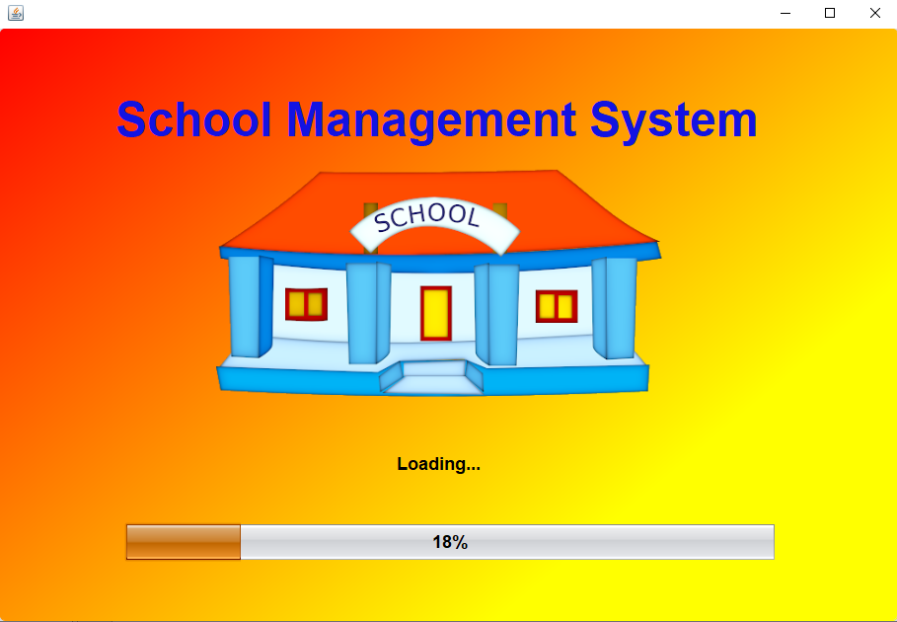

## 6.2 Secure login interface

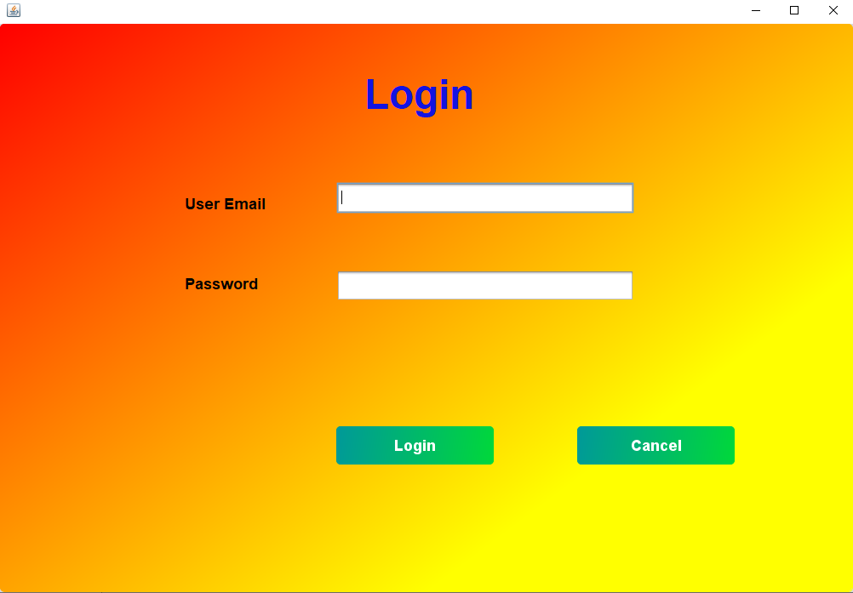

## 6.3 Home dashboard with navigation

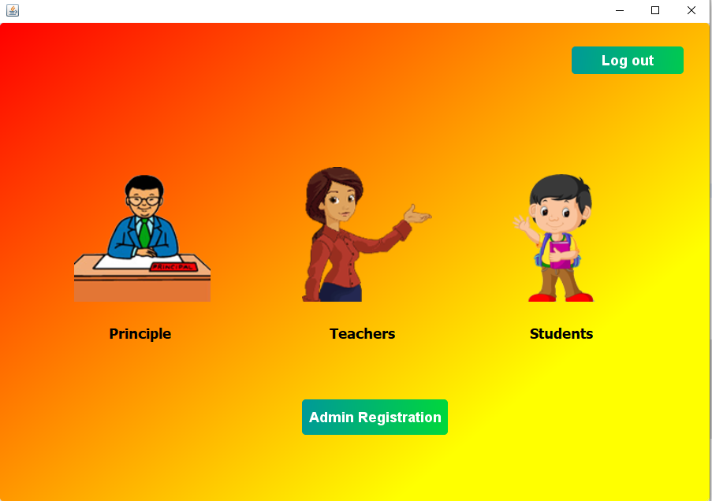

## 6.4 Principal management screens (Current Principle/view/edit)

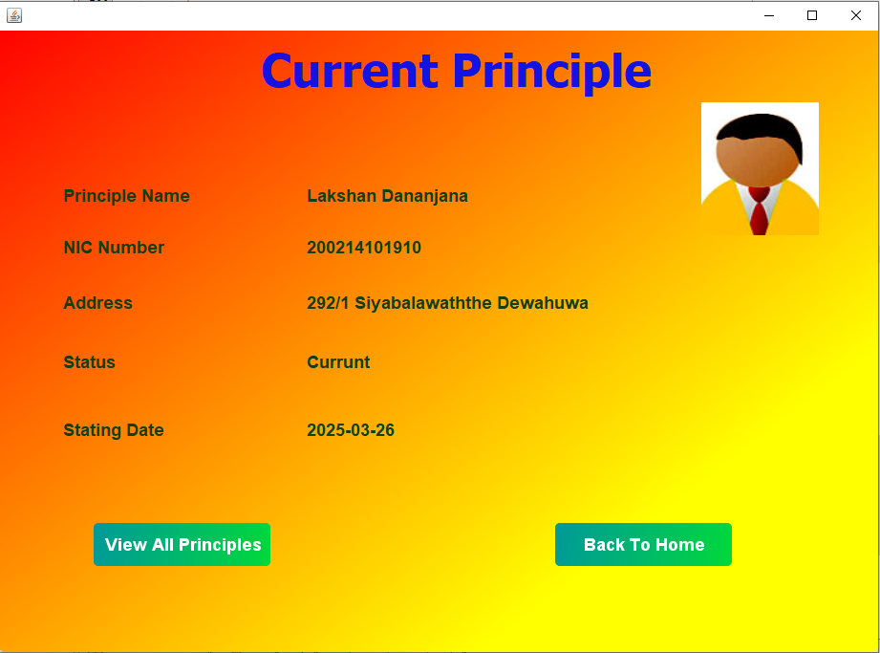

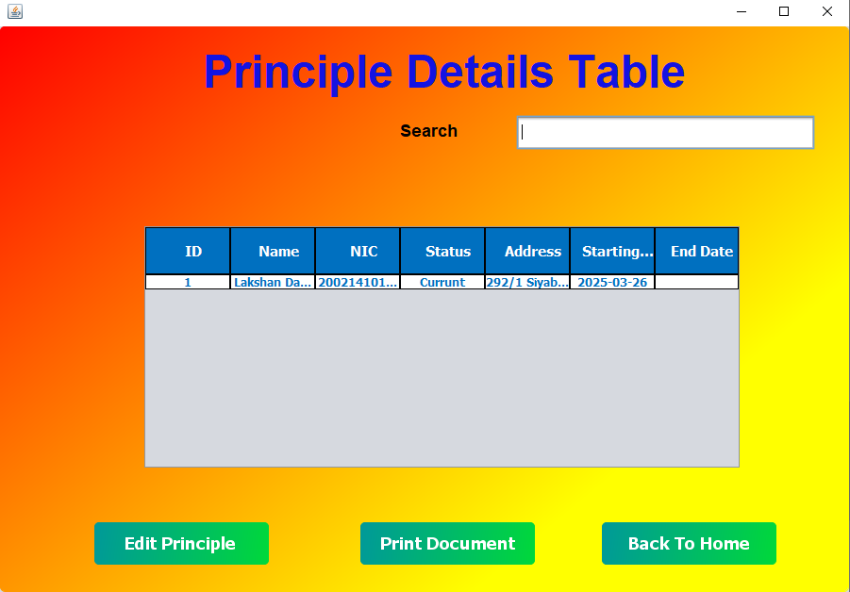

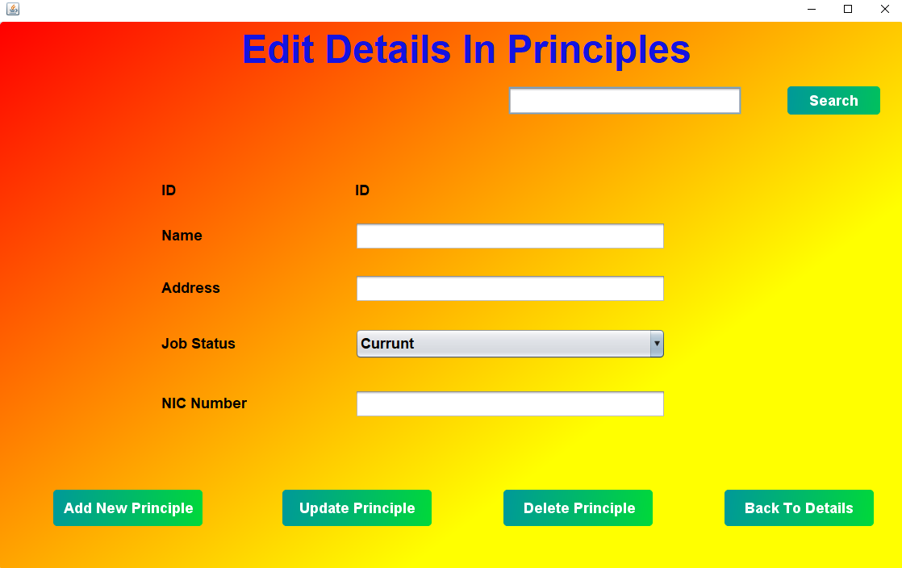

## 6.5 Teacher management screens (view/edit)

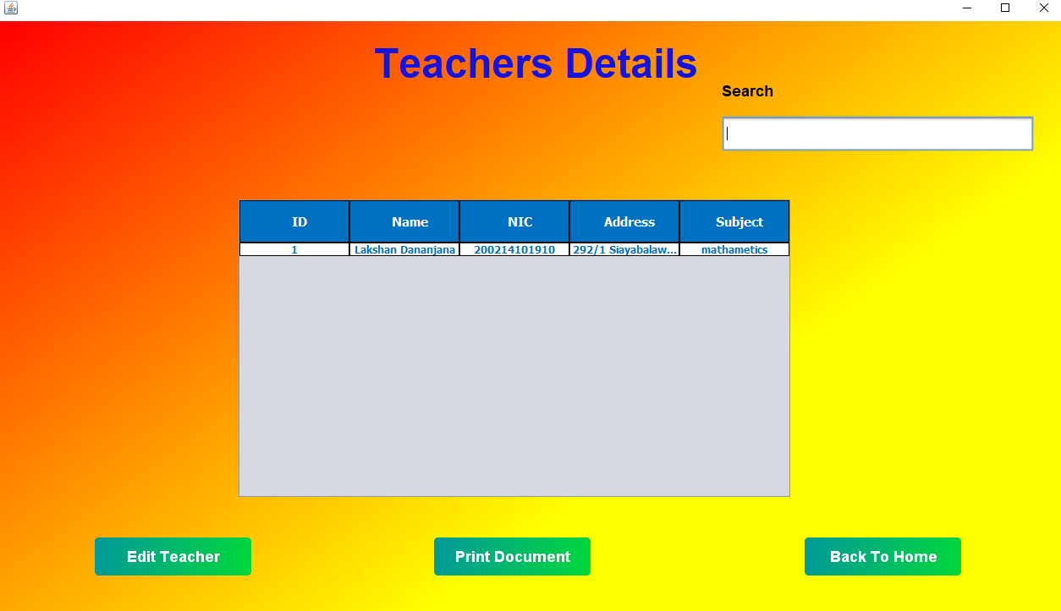

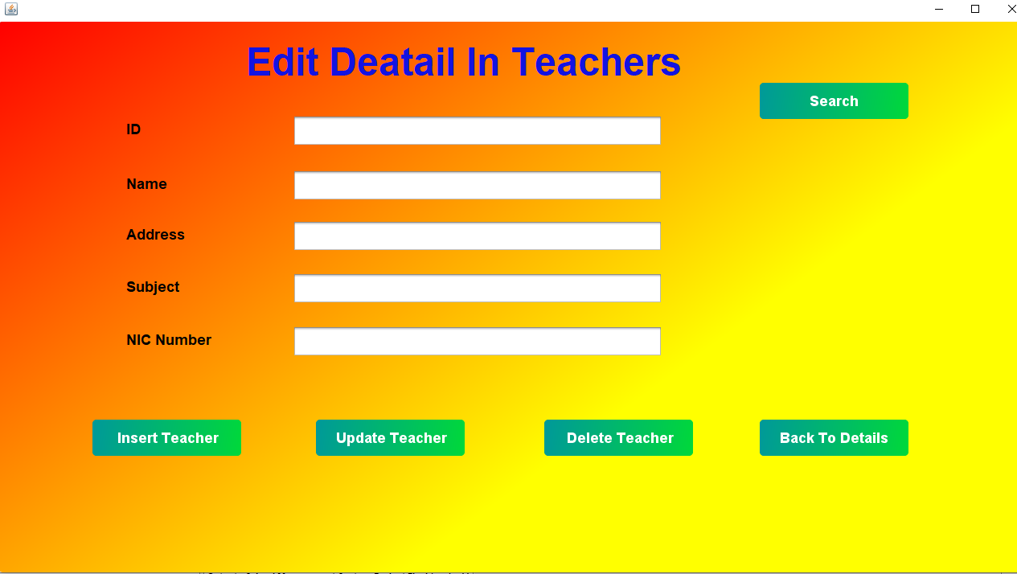

## 6.6 Student management screens (view/edit)

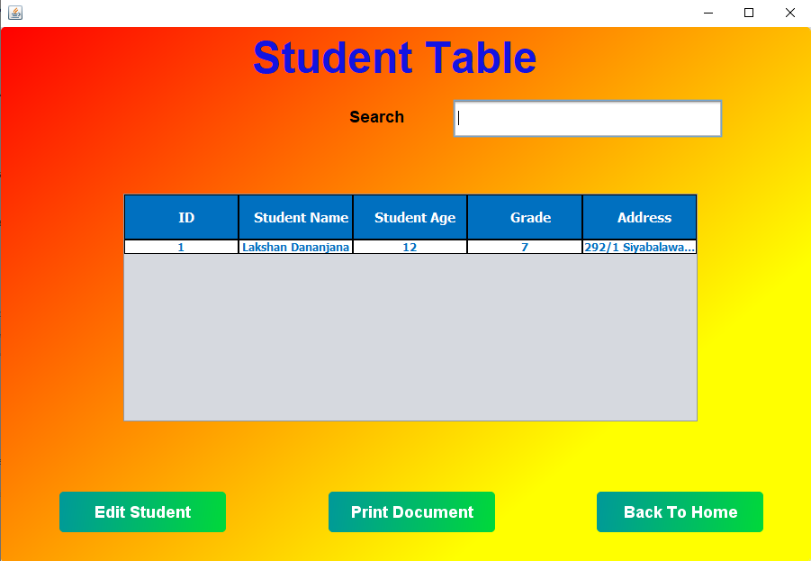

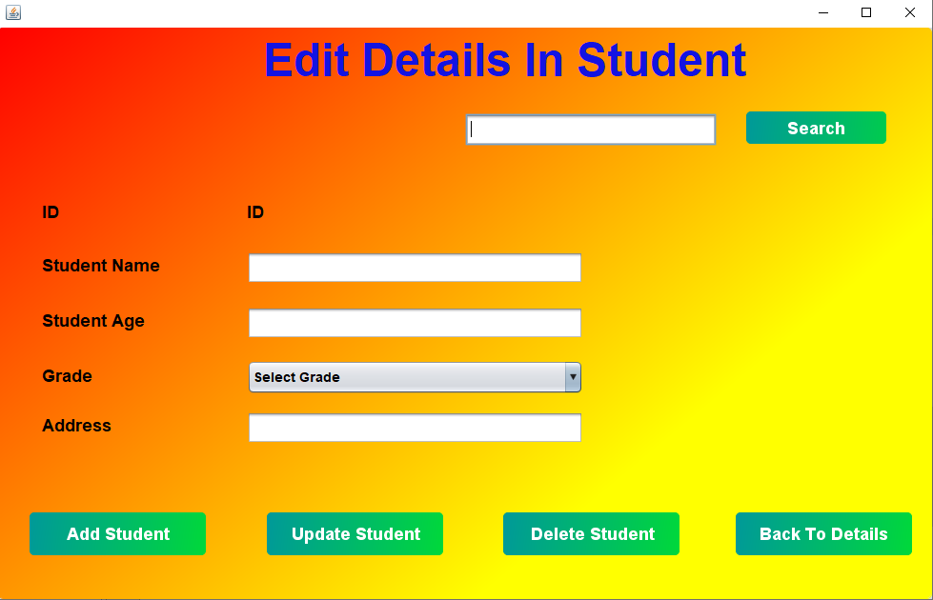

## 6.7 Admin registration interface

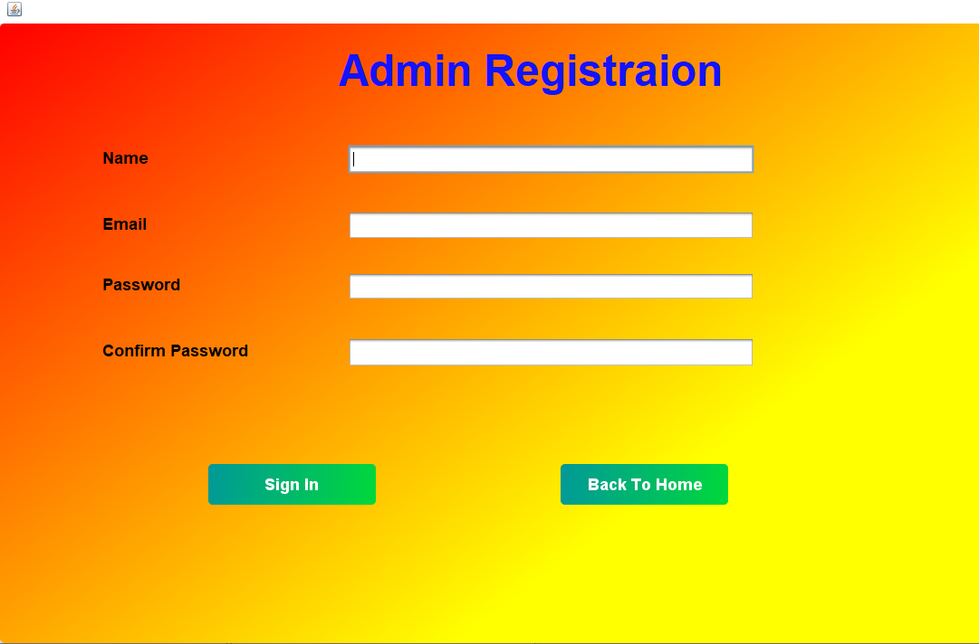

# 7. Development Process

## 7.1 SDLC Timeline

The project followed a structured timeline:

|  |  |  |
| --- | --- | --- |
| Phase | Duration (Weeks) | Outcome |
| Requirement Analysis | 2 | SRS Document |
| System Design | 3 | ER Diagrams, UI Mockups |
| Implementation | 6 | Core system development |
| Testing | 3 | Unit & Integration tests |
| Deployment | 2 | Test environment setup |

## 7.2 Key Diagrams

The system architecture was guided by:

### 7.2.1 Entity-Relationship (ER) Diagram

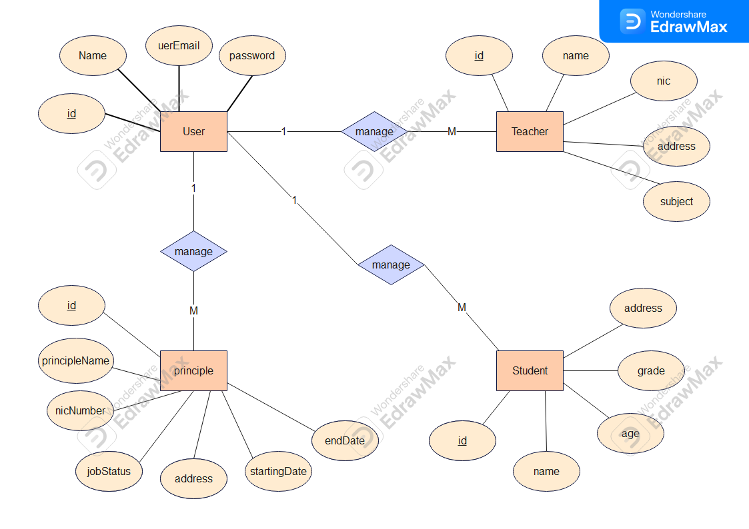

### 7.2.2 Data Flow Diagrams (Level 0)

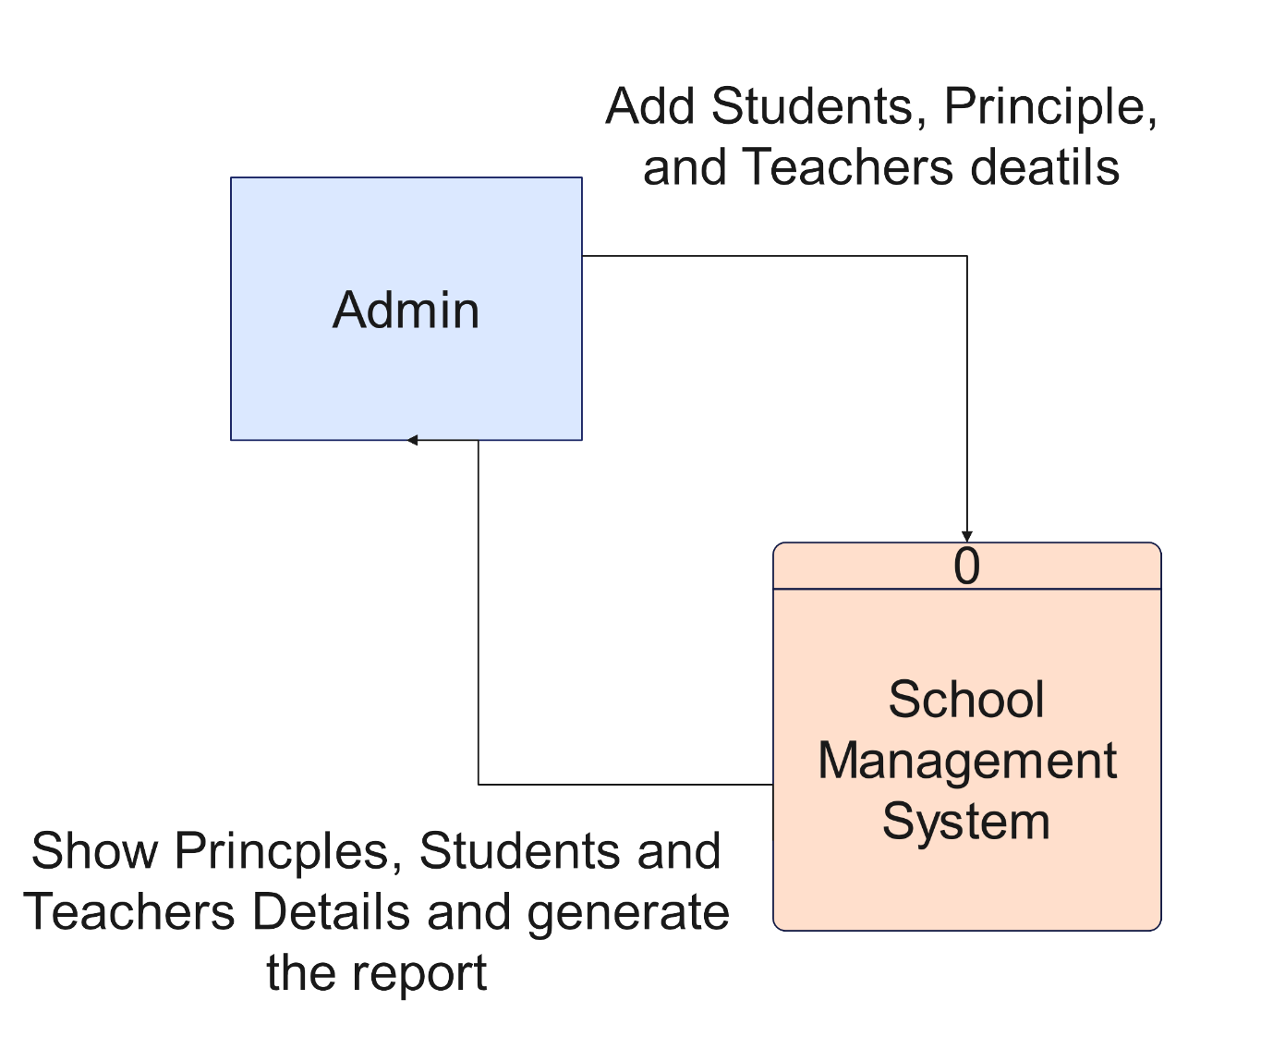

### 7.2.3 Data Flow Diagrams (Level 1)

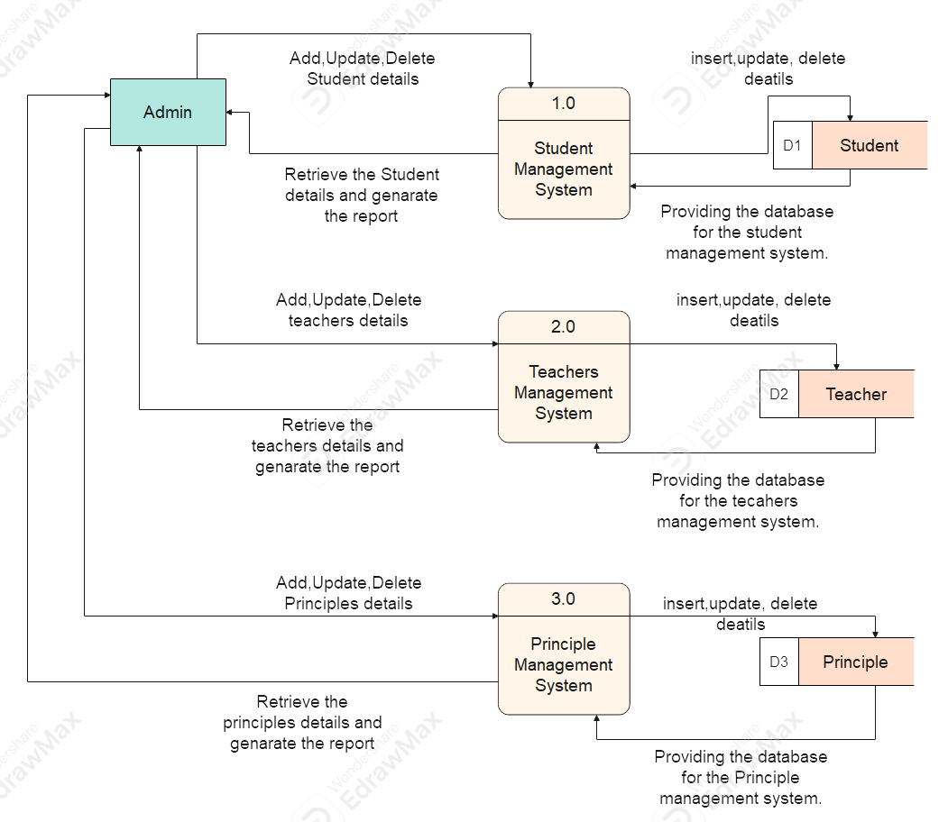

### 7.2.4 Use Case Diagram

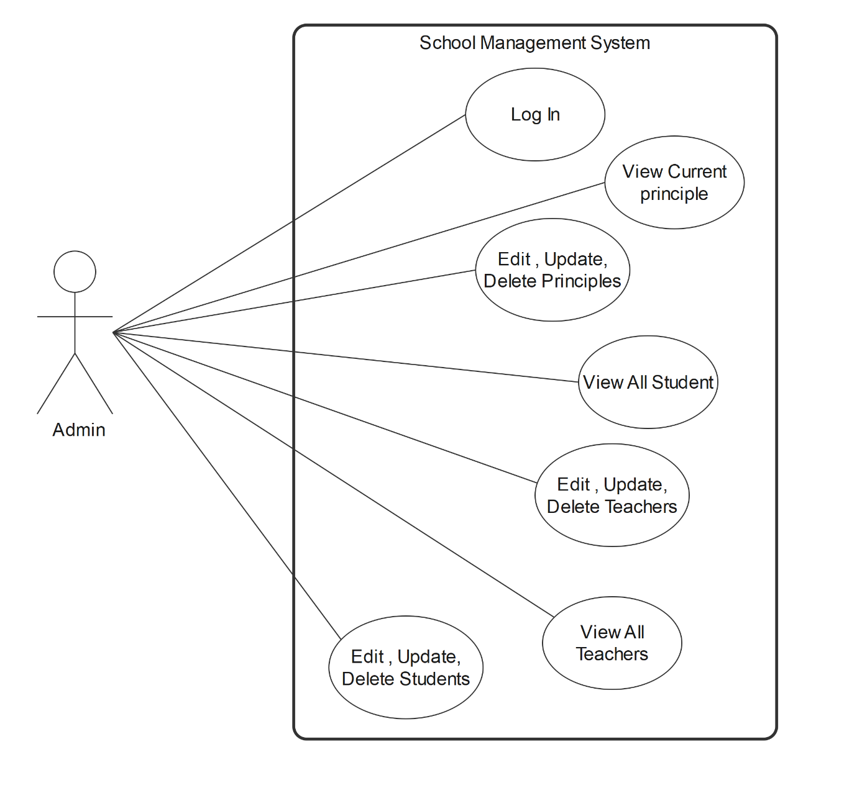

# 8. Testing Results

**Unit Testing**

* 95% code coverage achieved

**Integration Testing**

* All modules communicate successfully

**User Acceptance Testing**

* Positive feedback from school administrators

**Performance Testing**

* Meets all response time requirement

# 9. Challenges and Solutions

|  |  |
| --- | --- |
| Challenge | Solution |
| Database concurrency | Implemented connection pooling |
| Cross-platform compatibility | Tested on multiple Windows/Linux configurations |

# 10. Conclusion and Future Work

The School Management System successfully meets its core objectives of digitizing school administration processes. Future enhancements may include:

* Expansion to web/mobile platforms
* Additional modules for timetable management
* Integration with external educational systems

# 11. Appendix

References:

* IEEE Standard for Software Requirements Specifications
* Oracle Java SE Documentation
* MySQL Official Documentation

Prepared by:

[W. M. L. D. Weerasinghe]

[Developer]

[074 2449003]

[2024/ 07/ 17]